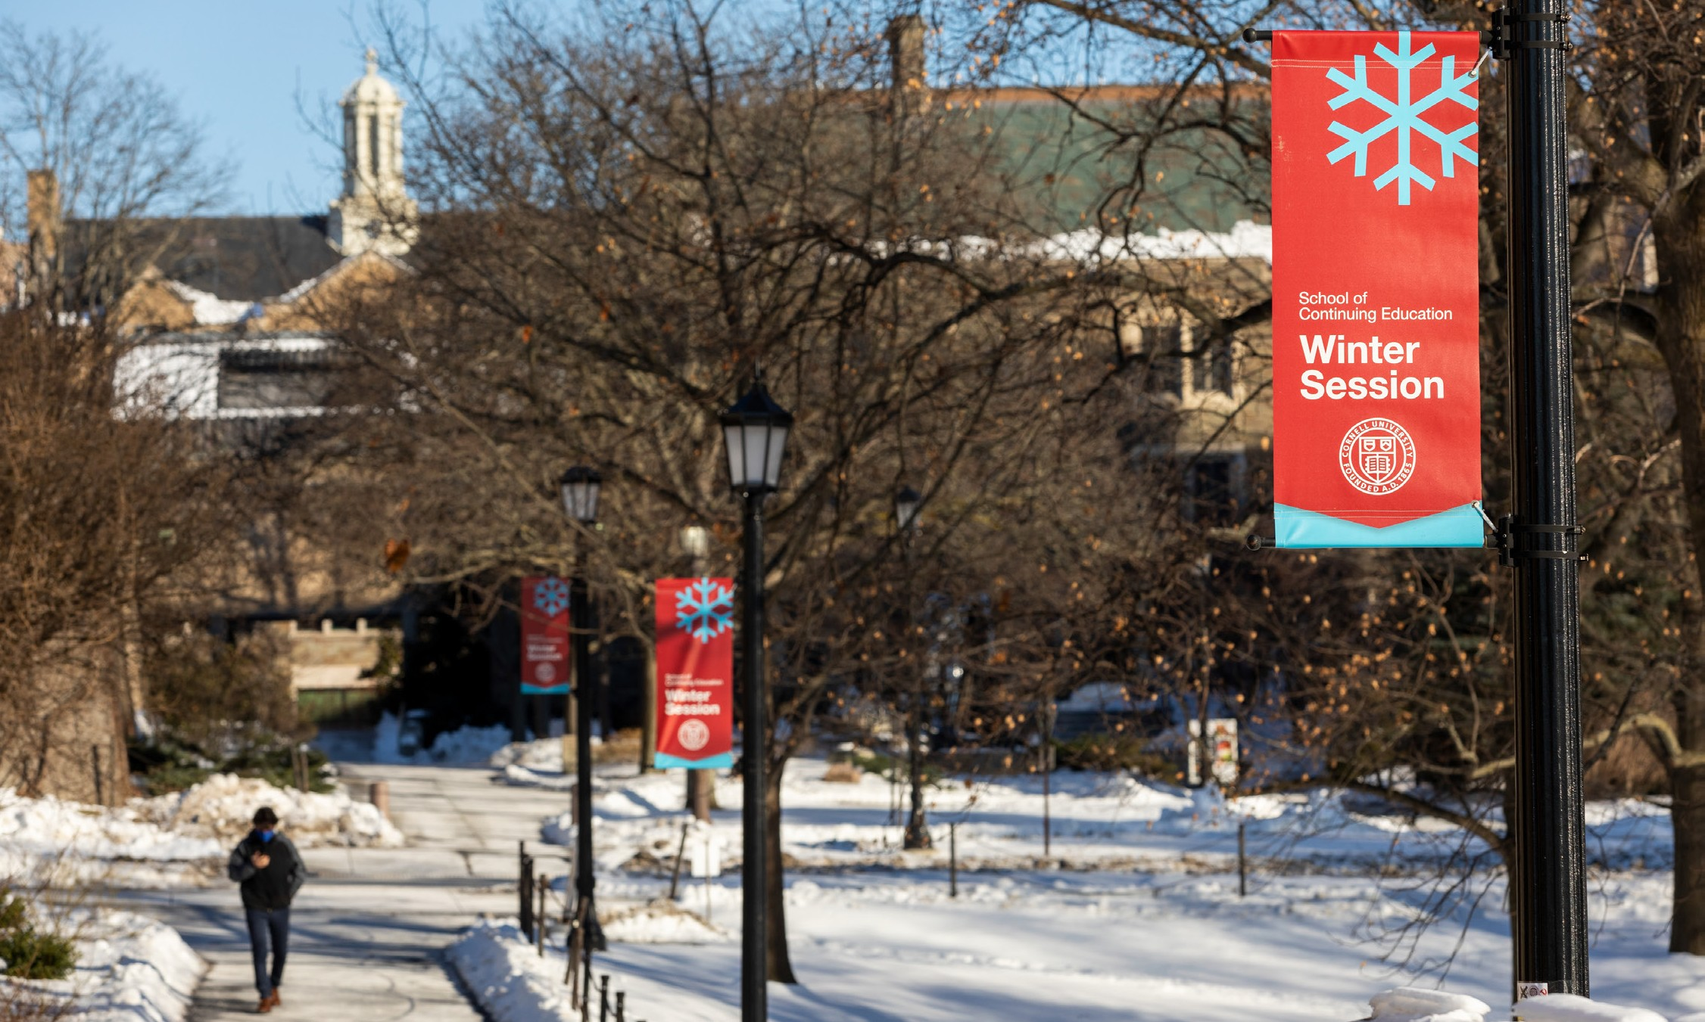
Winter Session 2024

Enter your course number and course title here. (Additional line provided here.)
Dates: Enter dates here Day/Time: Enter day and time here
Credits: Enter number of credits here Instructor: Enter instructor(s) here
Description: Enter course description here. Text will continue automatically on the next line to provide additional space.

For more information and to enroll, visit winter.cornell.edu. Contact us at cusce@cornell.edu

